LINEAR PROGRAMMING REVISION – MURDER BURGER

Murder Burger sells two types of burgers for lunch: the MOA burger and the WEKA burger.
It takes 3 minutes to make a MOA burger and 2 minutes to make a WEKA burger.
The total time available to make the burgers is 4 hours.
The cost of ingredients for each type of burger is $2.
The shop has only $200 available for ingredients for all the burgers.
The shop must provide at least 10 of each type of burger, but no more than 60 MOA burgers and 80 WEKA burgers.
The profit on each MOA burger is $2.20 and each WEKA burger is $1.

Step 1: Write inequations
This information may be useful (one equation per statement):
It takes 3 minutes to make a MOA burger and 2 minutes to make a WEKA burger. The total time available to make the burgers is 4 hours.

The cost of ingredients for each type of burger is $2.The shop has only $200 available for ingredients for all the burgers

The shop must provide at least 10 of each type of burger

no more than 60 MOA

No more than 80 WEKA burgers

Step 2: Draw Axis
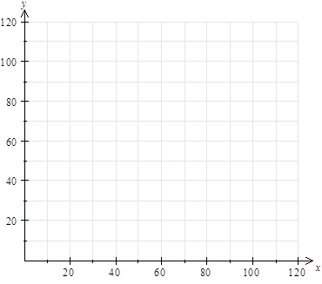
Step 3: Draw lines

Step 4: Shade out

Step 5: Find vertices of the feasible region
( , ) ( , ) ( , ) ( , )

Step 6: Write an equation for the profit
This information may be useful:
The profit on each MOA burger is $2.20 and each WEKA burger is $1.

Step 7: Find the maximum profit

Step 8: Write a statement answering the question.
Murder burger should make …..

